Subject:
Program to simulate the page fault process for variety of working set sizes from 2 through 20based on pseudocode attached
Name:
Course:
Professor:
University:
Date:

ANSWER

External to the program, generate a plot which depicts the performance of each of the algorithms.

Generate a memory trace

Each memory trace is 1,000 addresses.

Loop over parts from 0 to 9

Base address equals 25 times a uniform random value in [0,99], inclusive.

Index over addresses within part from 0 to 99.

Address[100*part+index] = Base + uniform random in [0,49], inclusive.

Basically, process a memory trace (1000 random number array with a work set of 2-20, so you process the work set of an array of two then once you process the 1000 numbers you do it again with an array of 3 then 4 and so on until the workset is 20 and one it's 20 you go back to a workset of 2, you do this 1000 times. And you do this for each of the 4 algorithm

A fault is when the address is not found in virtual memory (work set) so when you have a value in the trace you go through the workset if you find the number in the workset than there is no fault but if you don't have faults until the workset is full. So while you have values of 0 in the workset you don't have faults. Increase the fault count only when you have to replace an entry in the working set, which should only happen after the set is full.

Page Fault (Fault):
Occurs when the page containing a referenced word is not in main memory. This causes an interrupt and requires the proper page be brought into main memory.

Algorithms used for the selection of a page to replace:

Least recently used (LRU)
Replaces the page that has not been referenced for the longest time
By the principle of locality, this should be the page least likely to be referenced in the near future

First-in-first-out (FIFO)
Treats page frames allocated to a process as a circular buffer
Pages are removed in round-robin style
Simple replacement policy to implement
Page that has been in memory the longest is replaced

Clock:
Requires the association of an additional bit with each frame
Referred to as the use bit
When a page is first loaded in memory or referenced, the use bit is set to 1
The set of frames is considered to be a circular buffer
Any frame with a use bit of 1 is passed over by the algorithm
Page frames visualized as laid out in a circle

Random:
Random replacement algorithm replaces a random page in memory. In the random algorithm, you check if the next address in the trace already exists in your working set. If it doesn't, choose a random address within your working set and replace it with the new one.

Sample 1:
Numbers you need to feed into the working set are calculated in the "generate memory trace" function, which generates 1000 addresses (rand values from 0-99 *25 + some base address calculation) that you feed to your working set. The suggestion to use numbers from 1-5 with a buffer size 3, is so that you can compare the number of faults you get in your program with the example in the book (see below). It's just a way to validate your answer
Page address stream 2 321 52 4 5 3 252 OPT IRL,目困困困申困率團串串團團 LRU 222 5 5 553 333 2*22222* F page fault occurring after the frame allocation is initially filled
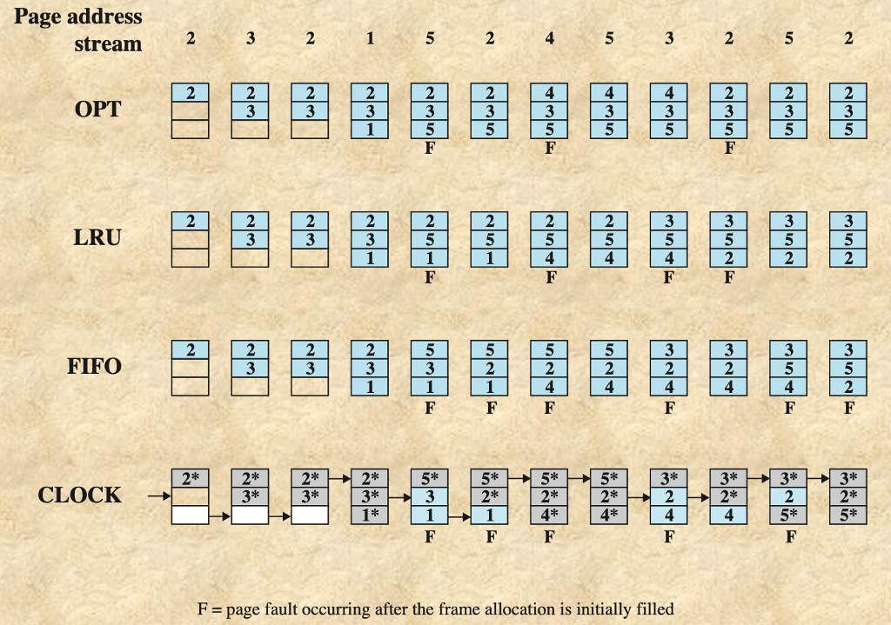

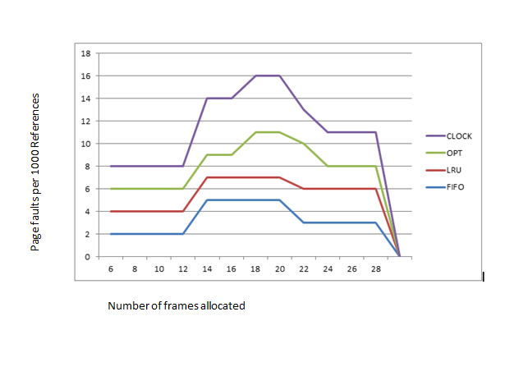
Fig. Comparison of Fixed-Allocation, Local Page Replacement Algorithms

